Name:_____________________________Period______Date____________
Quiz #1 The Mole

- (6) Find the molar mass of the following elements. Round to the nearest tenths place and include units!

  - B ______________ b) Pb ______________ c) He _________________

- (2) What is the mass (in grams) of one mole of Xenon?

- (2) How many atoms are in one mole of Xenon?

- (4) Acetaminophen (C₈H₉NO₂) is a chemical compound found in pain relievers, like Tylenol. Calculate the molar mass rounded to the nearest tenths place. 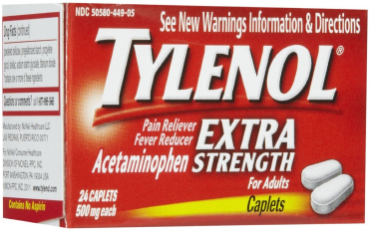

- (4) The recommended dose of Acetaminophen is 1.5 g C₈H₉NO₂. Determine how many molecules are present.

- (4)How many moles of carbon contain 1.65 x 10²⁴ carbon atoms?

- (4) When converting from grams to particles, why is it necessary to go through moles?
- (4) A sample of zinc contains 6.4 x10²⁴ atoms. What is the mass in grams of zinc?

- One swallow of water is about 20 mL of water.

      - (2) What is the molar mass of water?

      - How many moles of water are in one swallow? (Hint: 1g=1mL)

      - (4) How many molecules of water are in one swallow?

10. (6) Beaker A contains 3.5 moles of copper and beaker B contains 220 grams of silver. Which beaker contains the larger mass? Which beaker has the larger number of atoms? Support your answers with evidence.

