Titration Quiz Practice Name_________________________________

1. A student performs a titration to determine the concentration of a base. Use the information below to calculate the molarity of the base.
Write the balanced equation:

Calculate the M of the base.
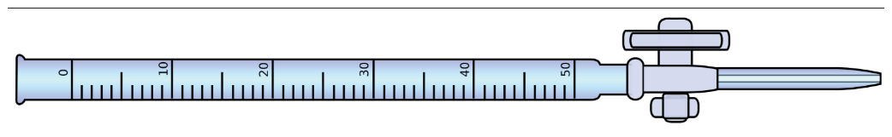
The acid is 2.7 M HBr and the amount used in the buret is 50.3 mL.
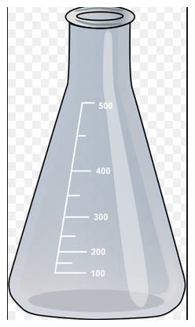
The volume of base, Mg(OH)₂, used was 22.7 mL. Indicator was also added.

2. A student performs a titration between KOH and H₂SO₄. The balanced equation is provided below.
2KOH + H₂SO₄ K₂(SO₄) + 2H₂O

The student fills the buret with H₂SO₄. The starting buret and ending buret volumes are shown below. The student uses a sample of base with a volume of 5.0 mL. What is the concentration, Molarity, of the base?
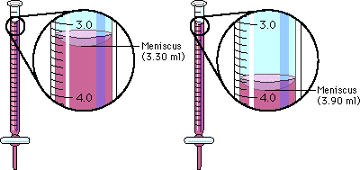

Start
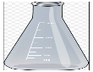
End

