Four Limiting Reagent Practice Problems

- Hydrazine reacts with dinitrogen tetroxide according to the equation:
2N₂H₄(g) + N₂O₄(g) → 3N₂(g) + 4H₂O(g)
50.0 grams of hydrazine is mixed with 100.0 grams of dinitrogen tetroxide. How much nitrogen gas was produced?

2. Nitrous oxide reacts with oxygen to produce nitrogen dioxide according to the equation:
2N₂O(g) + 3O₂(g) → 4NO₂(g)
What mass of nitrogen dioxide can be made from 42 grams of nitrous oxide and 42 grams of oxygen?

This one is from a quiz last year!
3. Suppose a solution containing 3.50 g of sodium phosphate is mixed with a solution containing 6.40 g barium nitrate.
  - Write a balanced equation.
  - Determine the limiting reagent.
  - Determine the amount of excess reagent left over in grams.
  - Calculate the amount of barium phosphate produced in grams.

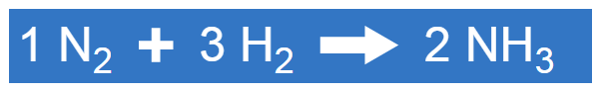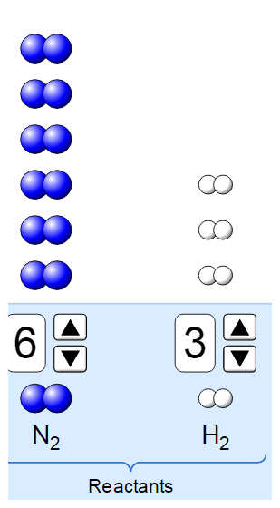

Determine the limiting reactant, the amount of each product produced, the amount of reactant left over, and draw a model of the products and left overs.

