Name: _______________________________________________ Date: ___________ Period: ___________
Reading a Triple Beam Balance
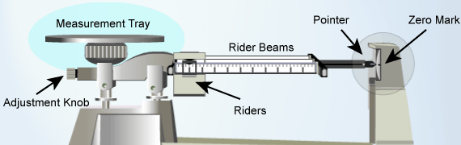
- In the science lab, we use a triple beam balance to accurately measure the mass of an object. What is the…
…function of the measurement tray? _________________  ________________________________________________ | …function of the beams with riders?__________________  ________________________________________________
…function of the adjustment knob? _________________  ________________________________________________ | …function of the pointer? __________________________  ________________________________________________
- Explain the difference between weight and mass. ______________________________________________________
_______________________________________________________________________________________________
- Suppose you did NOT calibrate (zero) the balance before finding the mass of an object. How might that affect your measurement? _________________________________________________________________________________ _______________________________________________________________________________________________
- Find the mass of the objects measured by the triple-beam balances shown below. Include grams (g) as the unit:
      

