Redox and Electrochem Practice Test Name_______________________________
Determination the oxidation number for the underlined element.
- Na₂SO₃ _______ 2. HNO₃ ___________
- H₂Se ________ 4. NiSO₄ ___________
- HClO _________ 6. AuCl₃ ___________
For each of the following, determine the species being oxidized, the species being reduced, the starting and ending charge.
- C + H₂SO₄ CO₂ + SO₂ + H₂O
Red = ________ Start Charge =__________ End Charge = ________
Oxid = ________ Start Charge =__________ End Charge = ________

- HNO₃ + HI NO + I₂ + H₂O
Red = ________ Start Charge =__________ End Charge = ________
Oxid = ________ Start Charge =__________ End Charge = ________

- Mg + 2HCl MgCl₂ + H₂
Red = ________ Start Charge =__________ End Charge = ________
Oxid = ________ Start Charge =__________ End Charge = ________

- 2Na + 2H₂O 2NaOH + H₂
Red = ________ Start Charge =__________ End Charge = ________
Oxid = ________ Start Charge =__________ End Charge = ________

Balance the following redox equations in acidic solution.
- H₂S + NO₃⁻ NO + S

- MnO₄⁻ + Cl ⁻ Cl₂ + Mn²⁺

Balance the following redox reactions in basic solution.
- Br₂ BrO₃⁻ + Br ⁻

- KIO₃ + H₂SO₃ KI + H₂SO₄

15. Consider the following pairs of half-reactions, decide which of the two half-reactions will occur at the anode and which will occur at the cathode, draw diagrams for the cells, and calculate the standard cell potentials:
a. Co²⁺(aq) + 2e⁻ → Co(s)
Ag⁺(aq) + e⁻ → Ag(s)
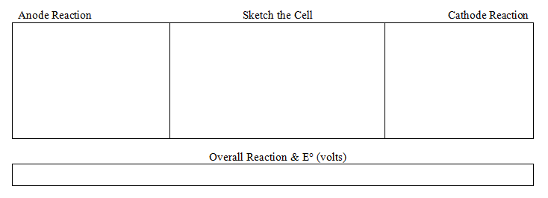

b. Ni²⁺(aq) + 2e⁻ → Ni(s)
Cu²⁺(aq) + 2e⁻ → Cu(s)

